

**Stay hungry. Stay foolish.**

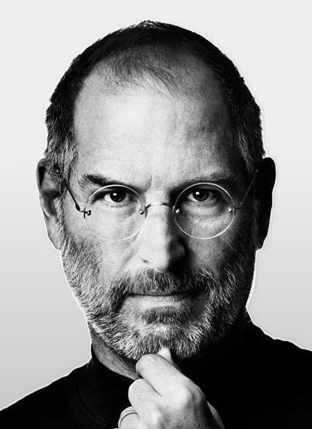

Steve Jobs

**(CEO of Apple Inc , February 24, 1955 – October 5, 2011)**

If today were the last day of my life, would I want to do what I am about to do today?